Marking screenshots for a design critique report

You can mark different areas of your screenshot using shapes and lines, then use numbers aligned to each visual component to reference them when discussing the visual design. Such an approach will make your reports easier to read and understand.

Let’s say you want to critique the visual design of the following screenshot:



This is an example of how to mark the screenshot for a design critique activity!

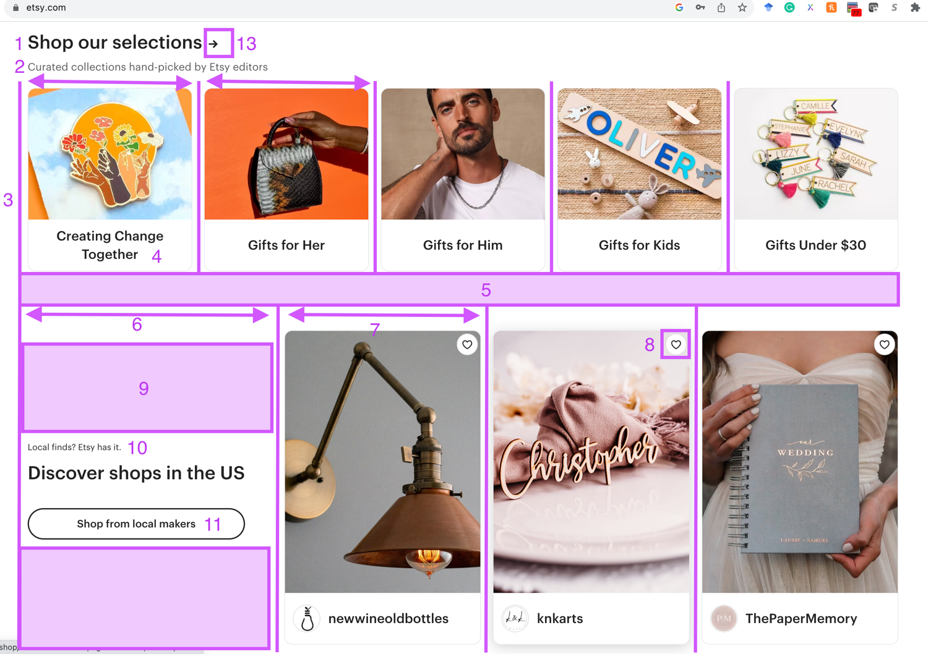

Of course, the above example is not the only way. You can be creative and come up with other ways to mark your screenshots to improve the readability of your report. Then use the indicators in your marked screenshot to reference different elements oof the design in your report. Here is an example of how to use the markups to make your report easier to read and understand:

*Following visual design includes two main grids, the top grip and the bottom grid each marked by parallel lines to indicate their columns. The white space marked by number 5 separates the two grids.*

*In the top grid, all columns are of equal width, while on the lower grid, the column marked by number 6 is wider that rest of the columns. …*